Mission of Serving the Poor: SEWA Rural
Dr. Gayatri Desai, Dr. Shrey Desai and Dr. Dhiren Modi were discussing their presentation to the board of trustees of Society for Education, Welfare and Action Rural (SEWA Rural), located in Jhagadia village in the district of Bharuch, Gujarat, India. The word SEWA in Hindi can be translated as “Service”. In the spirit of its name, the Trust runs several activities, including a 250 bed secondary care hospital, a vocational training program for rural youth, community health initiatives, etc. The three doctors represented the younger brigade of the trust and were deeply involved in planning its future course of action. The main agenda for the board meeting was Vision 2030: Where do they see SEWA Rural in another five to ten years?
Throughout the meeting, they asked themselves a few simple questions: What next for the Trust? Should they expand in terms of specialties offered in their hospital currently? Or should they spread and establish branches of this hospital in other regions in Gujarat, and perhaps the country at large? Or should they just consolidate their existing offerings in the same place? Could they successfully cope with the ever increasing patient load? All in all, what value addition were they creating and how could they improve further? In the upcoming board meeting they would be presenting their views on these, and many other similar, questions. All three were clear that their future plans had to carry forward the motto of the hospital: “Ati Adhunik Sewa, Ati Gareeb Maate!” In English, it simply means: “Excellence in service for the poorest of the poor”!
History of SEWA Rural
SEWA Rural started as a small hospital in the 1980s when a few young people, inspired by the principles espoused by Swami Vivekananda and Mahatma Gandhi, decided to leave their jobs in the US as doctors, to come to India and serve the needy. In a conversation with the case writers, Dr. Lata Desai, one of the founding doctors of SEWA Rural stated that their own humble upbringing, combined with huge poverty and unmet medical need they noticed during their student days, inspired her and her late husband (Dr. Anil Desai) to join hands with a few of their likeminded classmates and friends (Dr. Dilip Desai, Dr. Pratima Desai, Dinkar Dave, Jayashri Dave, Arvind Desai, Dr. Haresh Shah and Chaula Shah) to serve the neediest. Tribal Jhagadia had almost no medical facilities in those days, and people did not have access to basic health facilities. Further, all the founders, according to Dr. Lata Desai, have a spiritual bent of mind, and Jhagadia, to them, presented a perfect spot to start their mission: sufficiently far from their native place that they are no longer tied by social obligations and the imposing river, Narmada, flowing next to the village. To the people of Gujarat, Narmada is not just a river; to many it is an embodiment of divinity itself!
SEWA Rural was thus born in these idyllic surroundings, with an initial focus on primary and secondary care related to child and maternal health, general medicine and surgery. In an in interview, Dr. Lata Desai mentioned that according to founding members, this was the need of the hour for the place. They were able to recruit people from nearby towns to serve the nursing and paramedical functions in the hospital. However, the number of staff available to the hospital was very small. The founders decided that the only way to deal with this issue was by cross-training the staff. Further, they envisaged an organisation that enshrines the principles of equality and provides growth opportunities for all the employees. For example, Bankim Sheth, the current managing trustee of the Trust, joined SEWA Rural as laboratory technician during the early days of the organisation. During a discussion, one of the protagonists, Dr. Dhiren Modi recollected how he was given several opportunities to grow since he joined SEWA Rural in community health and research department as a public health professional, eventually ending up as the member of the governing trust.
SEWA Rural continues to operate in Jhagadia itself currently, and runs several initiatives. The organisation runs Kasturba Hospital (250 bed), community health and research initiatives, health training and resource centre, vocational training centre, and women’s empowerment program.
Changes at SEWA Rural Hospital
While the hospital continues to focus on child and maternal health, general medicine and surgery, it has also expanded into other areas like ophthalmology. Slowly the hospital's reputation grew in the neighbouring areas. Patients came to the hospital since they received good quality medical care at very low prices, and in many cases at no cost. However, the hospital also started seeing patients who needed tertiary care, which was not available. In order to ensure that such patients also get the care they need, the hospital developed a network of like-minded doctors. The hospital was then able to refer patients to these doctors ensuring that the same level of care was provided at the same cost. Equally important for the hospital were the to and fro linkages with referrals from the field. Exhibits 1a-1e present the growth figures of the hospital.
Even as the hospital has been expanding on the therapeutic front, it has also been transforming the way it handles existing functions. Since joining SEWA Rural in 2010, Dr. Gayatri Desai was instrumental in bringing forth several changes in the way the gynaecology and obstetrics division operated, keeping in mind some of the best global practices she observed in her previous employment. Upgradation of the labour room in the maternity ward, antibiotic usage in women who are going into labour, etc. are some of the initiatives she undertook at SEWA Rural. While implementing these changes, Desai tried to remain sensitive to the culture at the hospital and the organisation at large.
For example, she was instrumental in rationalising antibiotic usage to reduce post-operative infection rates. Further, encouraging normal deliveries, as against caesarean section operations, discouraging the practice of Kalla (pushing of the abdomen of the expectant mother at the time of delivery), etc. which are in line with the current recommendations of gynaecology are some of the other practices she institutionalised at the hospital. All these interventions along with changing the infrastructure of the neonatal ICU, training of the staff in infection control practices, observing the past data rigorously, enabled 90% reduction in new-born mortality at the hospital. Desai was clear that her intention was not to impose her ideas on the hospital, but to persuade her colleagues with evidence.
Other Initiatives at SEWA Rural
Defining health as the all-round development of the community, the trust which runs SEWA Rural did not limit itself to the hospital alone. Under the leadership of Dr. Pankaj Shah, one of the current managing trustees, the organisation undertook several community healthcare initiatives, especially in maternal child health. Doctors at SEWA Rural worked closely with ASHA and Anganwadi workers to ensure that pregnant women in the region are made aware of the care (medical and non-medical) during the pregnancy. As a result, neonatal and maternal mortality saw a sharp decline in recent years [Exhibits 2a and 2b]. Further, leveraging on their past experience of these initiatives, Dr. Shrey Desai, who joined SEWA Rural in 2010 (along with his wife, Dr. Gayatri Desai) and Dr. Dhiren Modi, who joined in 2007, were instrumental in deploying several technologically intensive applications like ImTeCHO and TECHO + to track the data of pregnant women (later extended to non-communicable diseases as well), so that timely help could be provided. These initiatives led to a further significant reduction in infant mortality in just one year.
The organisation also developed a health resource and training centre is aimed at bringing awareness to the local community on matters related to women’s health, adolescent health and menstrual hygiene. This centre leveraged technology to solve public health problems. Since 1985, SEWA Rural has been undertaking several initiatives aimed at primary education and women’s empowerment. Running tuition classes for children in classes one to seven, providing women with skill development and sources of employment are some such initiatives. Since July 2002, these activities have been transferred to an independent organisation, Sharada Mahila Vikas Society (SMVS).
In 1987, SEWA Rural started Vivekanand Gramin Techniki Kendra (VGTK) to provide vocational training to the local youth. The main objective of VGKT is poverty alleviation through skill development. It is a one year residential industrial and paramedical training program. Like all initiatives at SEWA Rural, training at VGTK aims at holistic development of the individual, including spiritual health. In the last thirty years or so, the program has managed to train over 3,500 people. With support from over 300 industries, they managed to place all the trainees in gainful employment, including a few who chose to be entrepreneurs.
According to its leadership, initiatives at SEWA Rural need two things at the core: service to the poorest of the poor, and the culture of cooperation and teamwork.
Culture at SEWA Rural
SEWA Rural believes that its culture is sacrosanct. When a Readers’ Digest article covered SEWA Rural in 1990, one of the founders, Dr. Lata Desai mentioned that the culture was based on three things: social service, scientific approach and spiritual outlook. Even today, the importance of these values on every aspect of their activities was repeatedly emphasised and were treated as non-negotiable.
The values that SEWA Rural emphasises are based on their mission of treating the poorest person with high quality medical service. The culture at SEWA Rural comes from the following eight core values: Honesty, Professional Transparency, Apolitical Approach, Equality of all religions, High Quality of Work, Integrity of Character, Family-like Bonding, and Spiritual Outlook. They also expressed a sincere belief in a data driven and evidence based approach. The founders also stated that trust in each other, sense of ownership and identification with the cause, and decentralisation and delegation of responsibility, are the central pillars of their culture. Over and above this, the seriousness of the motto of “Ati Adhunik Sewa, Ati Gareeb Maate,” was repeatedly emphasised by all the employees of the organisation, all the way from nursing staff to the trustees. For example, the head nurse of the maternity ward mentioned that serving the poor has been her prime motivation to join the organisation. everyone among the managing trustees and the other employees stated the importance of service to the poor being the primary objective. The quotes in Sarvadharma Temple (all faith temple) in the SEWA Rural — Shiv Bhave Jiv Seva (serving fellow humans like serving the God), Daridra Narayan (service of the poor is service to God), Atmano Moksharth — Jagat Hitaya Cha (for individual salvation as well as the welfare of the world), etc. — are the constant reminders of their true mission.
The idea of equality amongst all employees was another cornerstone that was repeatedly emphasised. Along with being a highly trained doctor, Shrey also is the son of Dr. Lata and Anil Desai, the founding members of SEWA Rural. Most of his childhood was spent on the premises of SEWA Rural in Jhagadia. As already noted, he and his wife Gayatri, joined the organisation in 2010. Although both were members of the trust, they enjoyed no special privileges. One of the managing trustees, Dr. Pankaj Shah noted that this core tenet is reflected in the salary structure at the hospital too. For instance, the ratio of salary of a senior doctor and the entry level workforce of the lowest cadre is about 12, and it keeps decreasing as the worker gains more experience. In other words, increments of lower rung workforce are steeper than the senior management of the organisation.
Similarly, the hospital has a common canteen for patients and employees. All members who come to the canteen are expected to wash their plates after they have finished their meal. This is a general rule that is applicable to all. The policies in the hospital are also supposed to reflect the values of transparency and equality. Respect for fellow employees comes across as one of the cornerstones of culture at SEWA Rural. For instance, Gayatri repeatedly emphasised implementing changes only through consensus and not forcing decisions. In order to socialise new employees in the culture, mentoring and training are undertaken by the hospital. There are regular refresher trainings that only focus on the culture of the hospital. The founders felt that culture was a differentiating factor for them and allowed them to attract talent to their hospital. It also ensured that the hospital was able to meet its mission. The same spiritual underpinnings and organisational ethos seem to spread to the other initiatives that are run by the trust as well.
The COVID-19 pandemic tested the culture of SEWA Rural. Other than the hospital, which was considered as an essential service, the other divisions of SEWA Rural (community health initiatives, vocational training, children welfare, etc.) could not operate. However, according to Dr. Pankaj Shah, letting go of any employee was not an option. The hospital employed all of the workforce, and figured out work for them. Further, no salary reductions needed to be carried out. Pankaj further added that the only thing that the employees have voluntarily foregone is the annual increment, and many of them contributed a part of their salaries to the organisation. Dedication to the cause — service to the poor — united them in this effort. Furthermore, donors who regularly contribute to SEWA Rural have also stepped up on their contributions, thereby enabling the organisation to meet its financial commitments to its employees.
Even as ensuring that the impact on the poorest section of the society remains their focus, there has been no compromise on scientific rigor and experimentation. SEWA Rural has always facilitated its doctors to publish regularly in leading peer reviewed journals. While encouraging experimentation, the organisation looks for individuals with a long term commitment who can anchor the cause before all other initiatives. Summarising this, Shrey pointed out that, “First is always the Who. Then comes What. We find the commitment to organisational goals to be an important Driver to success than technical know-how.” Probably, for this reason, SEWA Rural continues to invest in primary and secondary care, but relies on linkages to provide tertiary care. It intends to remain a mid-sized organisation, but would like to work on issues with wider impact. According to Shrey, remaining mid-size allows the organisation to spend their funds more effectively and permits the luxury of concentrating on ati adhunik seva (best possible service) for the ati gareeb (poorest of the poor). Genuine teamwork, absolute lack of founder-centricity, apolitical approach, were the other themes that kept recurring in every conversation at SEWA Rural. Creating tangible and demonstrable impact rather than spreading thin, seems to be the motto at SEWA Rural thus far.
It is interesting to note that while SEWA Rural continues to operate in Jhagadia, several people who worked with and trained at SEWA Rural have gone on to create similar organisations in other parts of the country. The experience gained at SEWA Rural seems to continue to inspire them long after they leave the organisation. For instance, the founders of Shaishav: Falgun Sheth and Parul Sheth, who used to work with SEWA Rural at one point, and have gone on to found their own organisations. They fondly remember working with Dr. Anil and Dr. Lata (founding members) in the initial days of SEWA Rural. Feeling inspired by the values at SEWA Rural — especially related to integrity, transparency and service to the poor — they started Shaishav which works with the rights of marginalized children in rural Gujarat (Bhavnagar). While the purpose, strategy, and funding partners are quite different from SEWA Rural, they felt united in spirit and in pursuit of values. All the trustees of SEWA Rural recollected many of its ex-employees and people associated with it in the past fondly and shared how the organisation continues to support many of them on several fronts even today.
Sources of funding for SEWA Rural
Exhibit 3 presents the revenue sources for the past four years for SEWA Rural. Their sources of revenue are grants from the government (both central and state), institutional and personal donations, income from patients (marginal fees charged from the patients who can afford it) and government schemes (like government provided insurance mechanisms) and some other internal sources. The trust is actively trying to establish a corpus, which would provide some buffer for any unforeseen expenditures.
Recognition at SEWA Rural
For its focus on community and the rural poor, SEWA Rural has been conferred with several awards of international repute. In the interest of space, we list only a few here, and refer to their website for further details. SEWA Rural has been consistently recognised among the great places to work by the organisation: Great Place to Work, a global organisation that certifies work places. It was especially recognised for its women employee friendly environment. The Government of India too recognised the contributions of SEWA Rural, when Dr. Lata Desai received Padma Shri (India’s fourth highest civilian honour) in 2022, for her contribution to health and social services to the rural and tribal regions of Gujarat. The World Health Organisation (WHO) has awarded them with the inaugural Sasakawa Award in 1985 for pioneering work in community health. Recently, the WHO also conferred the Public Health Champion Award for their contributions to public health. In 2007, the organisation was conferred with the Mac Arthur award in the category of creative and effective institutions. In 2014, in recognition of SEWA Rural’s expanding vision and role, it was conferred with the SKOCH Financial Inclusion Award.
Conclusion
As Shrey, Gayatri and Dhiren continued their conversations on the future plans for SEWA Rural, in 2030, they were clear that the unique culture at SEWA Rural could not be compromised. The motto — providing the best service to the poorest of the poor — has to remain enshrined in all their activities.
Questions for discussion:
What could be some of the recommendations for Mission 2030? Where else should SEWA Rural expand? And how else could it increase its impact given its current strengths and limitations?

Exhibits
Exhibit 1 a: Growth of OPD
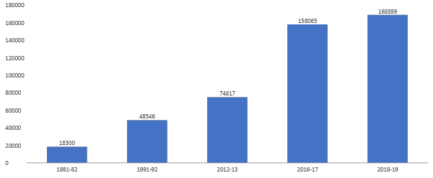
Source: SEWA Rural
Exhibit 1 b: Growth of Indoor Patients
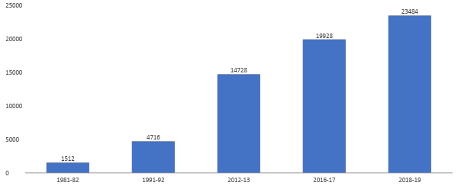
Source: SEWA Rural

Exhibit 1 c: Growth in Deliveries at the Hospital
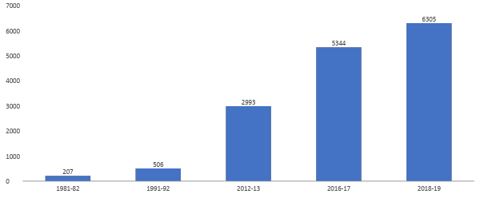
Source: SEWA Rural
Exhibit 1 d: Growth in Surgeries across all departments
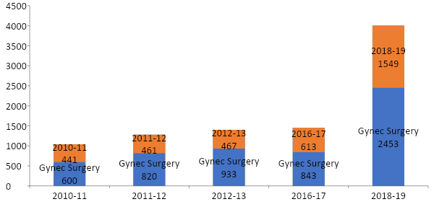
Source: SEWA Rural

Exhibit 1 e: Growth in Ophthalmology (OPD and Surgical)
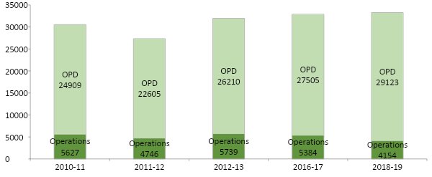
Source: SEWA Rural
Exhibit 2a: Maternal Mortality of Jhagadia Block
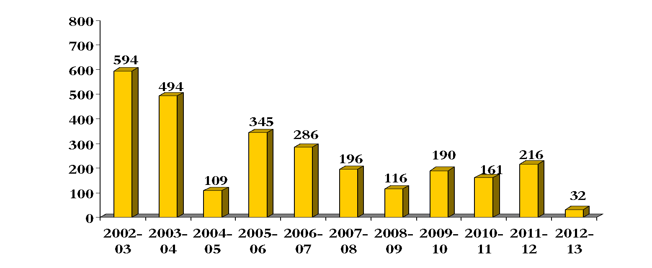
Source: SEWA Rural

Exhibit 2b: Neonatal Mortality Rate of Jhagadia Block
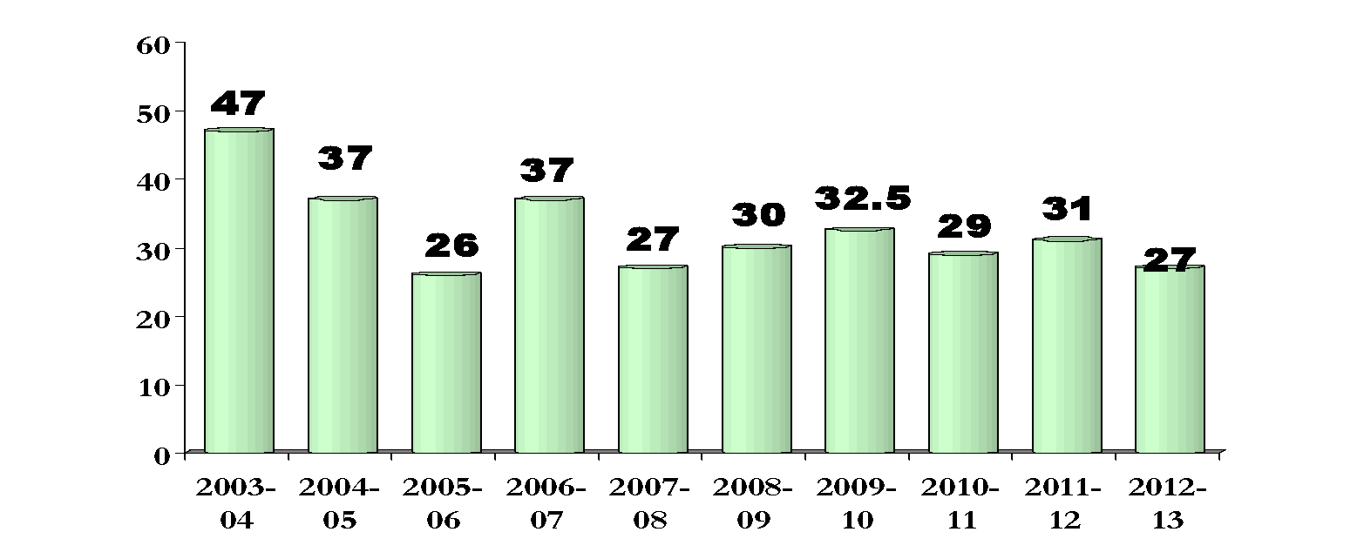
Source: SEWA Rural
Exhibit 3: Revenue Sources for SEWA Rural
Diverse Sources of funds (%) (recurring)
 | 2020-21* | 2019-20 | 2018-19 | 2017-18
Grant (Government and Others) % | 24 | 34 | 42 | 27
Institutional/ Personal Donation % | 39 | 19 | 13 | 20
Patient income & Govt. Schemes** % | 16 | 32 | 31 | 32
Internal Source & others % | 21 | 15 | 14 | 21
Total recurring revenue | INR 188.8 million | INR 161.4 million | INR 161.1 million | INR 124.9 million
Sources: SEWA Rural annual reports
* Due to COVID, there was a reduction in the income from government grants and schemes

Before joining SEWA Rural, Gayatri was a practicing gynaecologist at Fairfax Innova Hospital in Virginia.
Shah, P., Shah, S., Kutty, R. V., & Modi, D. (2014). Changing epidemiology of maternal mortality in rural India: time to reset strategies for MDG‐5. Tropical Medicine & International Health, 19(5), 568-575.
Modi, D., Saha, S., Vaghela, P., Dave, K., Anand, A., Desai, S., & Shah, P. (2020). Costing and cost-effectiveness of a mobile health intervention (ImTeCHO) in improving infant mortality in tribal areas of Gujarat, India: cluster randomised controlled trial. JMIR mHealth and uHealth, 8(10), e17066.
Shanoo Bijlani (1990). The Good Doctors of Jhagadia. Readers’ Digest. September: 125 - 132.
SEWA Rural (n.d.) About us. Retrieved from https://sewarural.org/who-we-are/

